

**Retailer Newsletter**

**July 1, 2020**

**Tom’s Business “TIPS”**

***“To Improve Profits”***

**RE: *Fountain Drink Service***

**Hello,**

**There are very few c-stores I visit that do not have a cold drink fountain machine and all stores sell coffee/cappuccino. We all are faced with the issues of having a dispenser ‘Out of Product’, CO2, or other issues forcing us to shut down 1 or 2 flavors, or worse yet the entire machine.**

**I recently found the sign, see photos below, *(1 & 2)* at a local store. I liked the sign and asked the manager where she found them. She told me they had been at the store for years and nobody knows where they came from. I believe they looked professional. The two signs, photos below *(3 & 4)* also look good. Sign #4 is printed on post-it-note paper and simply sticks to the fountain head. My discussion regarding ‘Out of Order’ fountain machines and coffee dispensers would not be complete without a couple of poor examples of signage. Check out #5 & 6, they speak for themselves.**

**There were times when I owned my stores that I needed an Out of Order sign for my fountain or coffee. It does happen to of us so why not be prepared for the inevitable.**

**1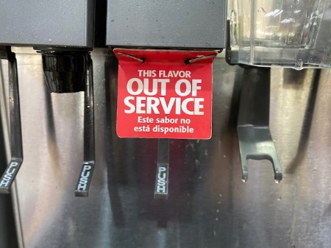 2**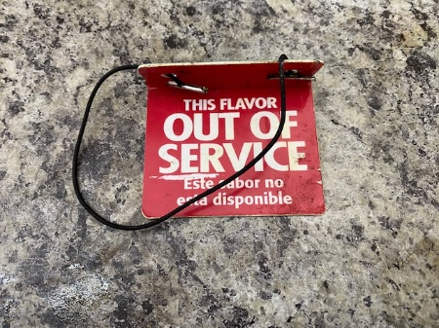

**3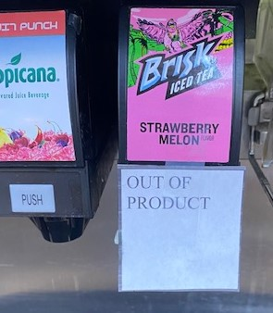 4**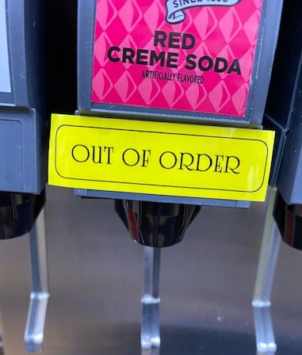

**5 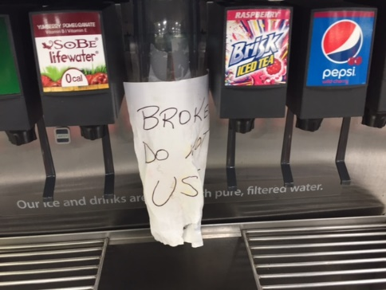 6**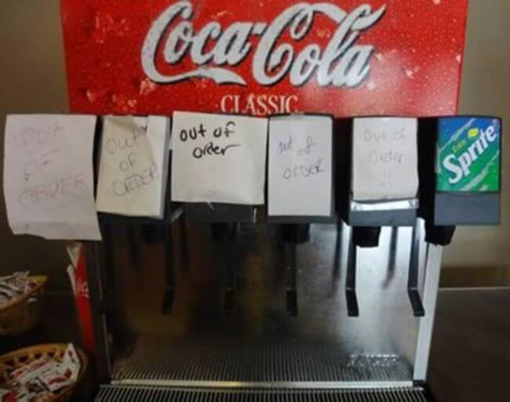

***Added customer ideas:***

**I hope you have Hand Sanitizer in your stores for customer use. I like the touchless dispensers (A). I also think you should have a touchless paper towel dispenser (B) and soap dispenser (C) in the restrooms. My stores always had an electric hand dryer as well as paper towels. That was my way of being sure the customer always had something to dry their hands with, if the paper towels ran out between our restroom checks. I believe this is an added customer service.**

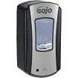 **A 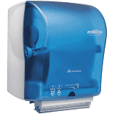 B 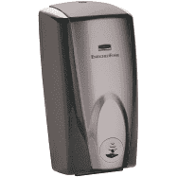 C**

**I’ve been around long enough to remember the days when we started selling self-service gasoline. The customers (especially women) were concerned with getting dirty. We had oversized plastic gloves customers could slip on and keep their hands clean. With everyone concerned about ‘clean’ today, it might be a good addition to your store. Here’s the link:**

<https://www.cstore1.com/gas-mitt-intro-kit/14-0120/>

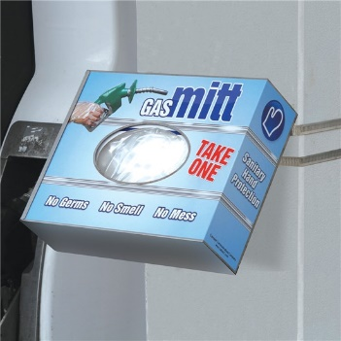

**If you’re afraid they will be stolen, have them available inside your store, well-marked so customers can easily find them and know what they are for. I believe your regular customers will make the effort to come inside and get one. I believe these items upgrades the Customer Service at your store.**

**Many of you have attended our latest seminar called “Safety & Security”. During this session, I often ask, “Do you really care about the safety of your staff?” I always hear a resounding, “YES!” then I have a couple of questions to ask that will give your staff some insight into your true feelings. What if: you receive a call from one of your CSR’s reporting a recent hold-up at your store. If you reply, *“How much did they get?”* You failed the test. You should have asked*, “Is everyone OK?”* Here’s another possible scenario, one of your CSR’s calls and tells you they have been involved in an accident on their way to work today, and you reply, *“Are you going to make it* *to work today?”* You flunked again. Your first comment should have been, *“Are you OK?”* You see, it's easy to say, “I care about my employees”, but does it really show? I hope this helps.**

**I hope you; your stores, staff, and family stay safe during these trying times.**

**Don't be a victim of the 5 Dangerous Words –**

***‘Maybe I’ll Do It Tomorrow’***

**Do it today because tomorrow (~~could be~~) will be too late!**

**Tom                                                                       
Thomas W. Terrono  
T&S Management Services, LLC  
Instructor / Consultant for the Convenience Store Industry  
Lee's Summit MO 64082-4864   
816.550.8048**



**[tom.tsms@gmail.com](mailto:tom.tsms@gmail.com)**

[**www.tsmanagementservices.com**](http://www.tsmanagementservices.com)

***“Our business is making your business better!”***